# Compass - Override Flags

Editing Override Flags

Locating Specific Override Flags

Override Flags When Creating an Override

Standard Override Flags

Related Documents

**Description:** This document provides information for editing overrides (flipping flags) in Compass to ensure appropriate application of overrides. Edits to flags may be necessary in Compass when the override does not pay.

|  |
| --- |
| Editing Override Flags |

Refer to the following to locate override flags in Compass:

|  |  |
| --- | --- |
| **Step** | **Action** |
| **1** | From the Claims Landing Page, click the **Override/PA History** hyperlink from the **Quick Actions** panel.    **Result:** The Override History screen displays. |
| **2** | Locate the override in question from the **Override History** section and click the **ID #** hyperlink.  **Result:** The Override Details screen displays with Override Flags. |
| **3** | Edit the appropriate override fields based on the type of override. Refer to the applicable override work instruction or reference table. |
| **4** | After the appropriate override fields have been edited, click the **Save Changes** button at the top of the screen.    **Result:** The Reason for Editing popup displays. |
| **5** | Choose the appropriate reason for editing the override from the drop-down menu and then click the **Save Change** button.    **Result:** A banner displays with the following message: “The update was successfully applied for XXX” |

Top of the Document

|  |
| --- |
| Locating Specific Override Flags |

Refer to the following to identify the location of specific override flags that may need to be edited in Compass:

**Common Overrides Flags:**

The following displays the location of flags within the **Common Overrides** section, outlined in red:

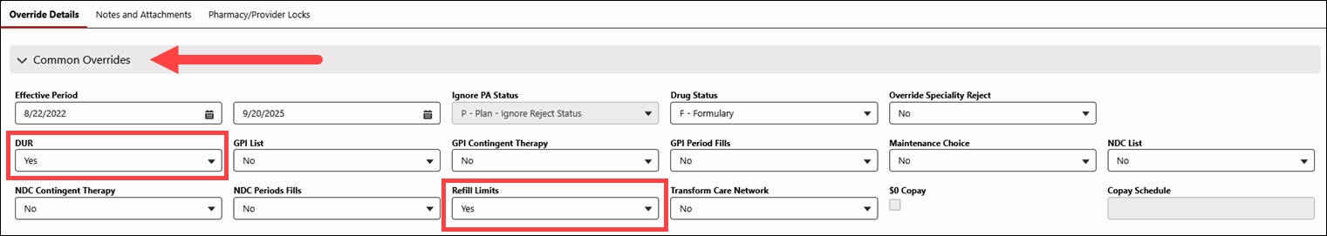

**Requires Special Handling Flags - General Tab:**

The following displays the location of flags within the **General** tab, outlined in red:

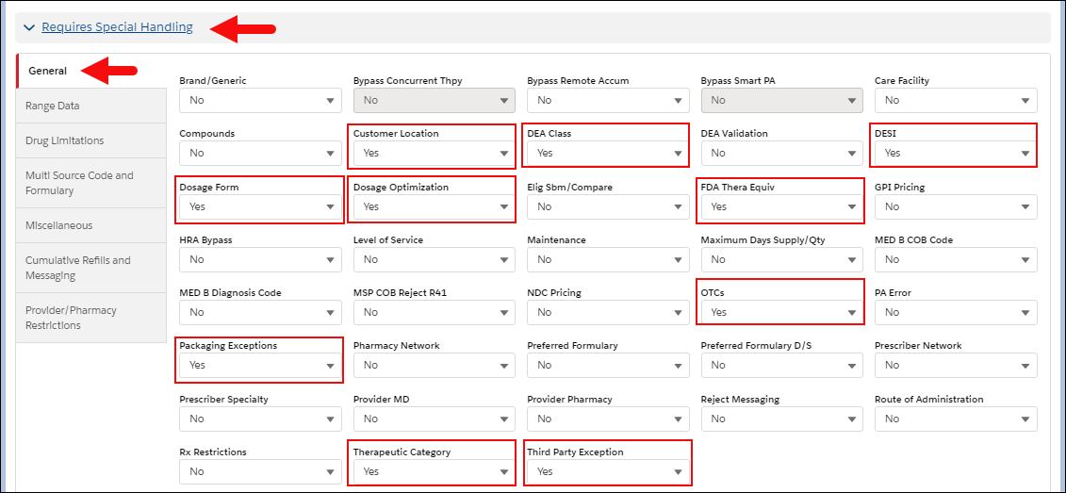

**Requires Special Handling Flags - Range Data Tab:**

The following displays the location of flags within the **Range Data** tab, outlined in red:

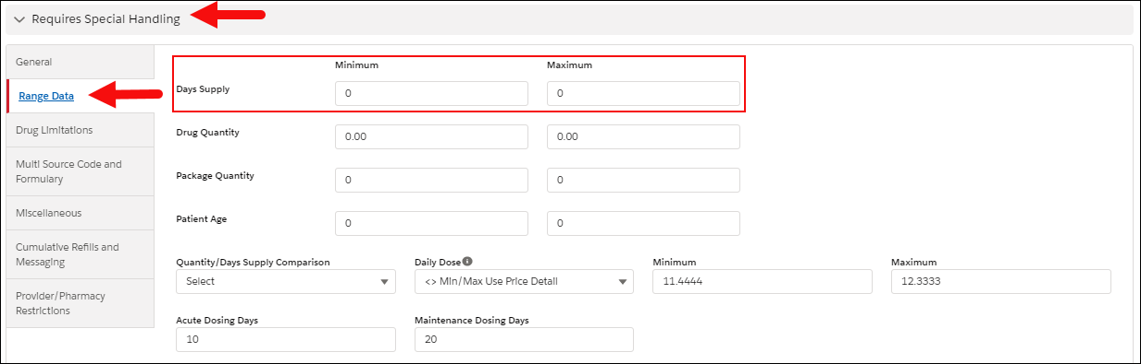

**Requires Special Handling Flags -** **Drug Limitations Tab:**

The following displays the location of flags within the **Drug Limitations** tab, outlined in red:

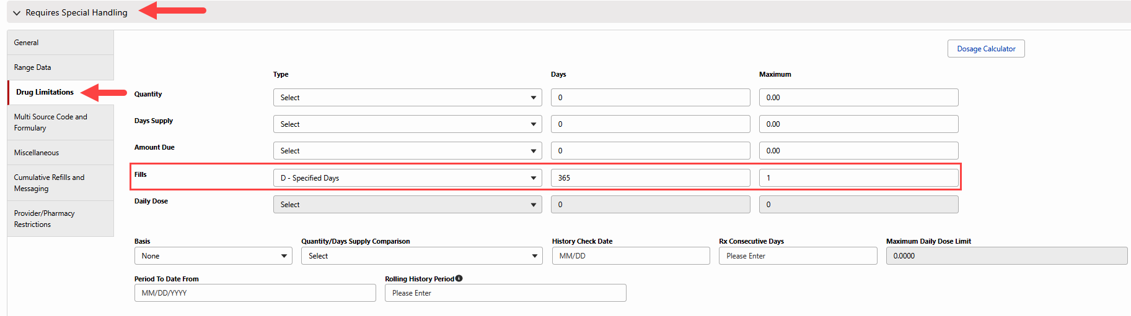

|  |
| --- |
| Override Flags When Creating an Override |

 If the following popup displays enter required notes:  **Client requires detailed notes on why override is being authorized.**

**Note:**  Requestor, Relationship to Member, and Authorized By are automatically inserted as notes (to view, access Override/PA History from the **Quick Action** panel on the **Claims**tab by clicking on the **Override ID** and then the **Notes** tab).

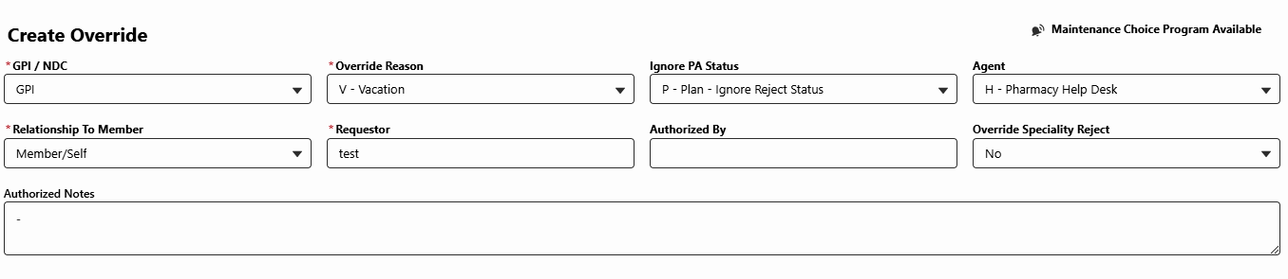

|  |  |
| --- | --- |
| **Field Type** | **Description/Instruction** |
| **Ignore PA Status** | Leave as P-Plan Ignore PA Status (default), or as instructed by the **CIF**. |
| **Agent** | Defaults to **H-Pharmacy Help Desk**. Customer Care agents **WILL** need to change this to **P – Plan Sponsor** by selecting the **Agent** dropdown. For any other selections, edit only as instructed by the CIF |
| **Relationship** **To Member** | Auto populates with information from Authentication screen. If not, select the correct option from the dropdown menu. |
| **Requestor** | Auto populates with information from Authentication screen. If not, enter the requestor’s name. |
| **Authorized By** | Edit only if the **CIF** shows documentation is required or provides other instructions. |
| **Override Specialty Reject** | Defaults to No. Edit only if rejected for Specialty medication, or as instructed by the **CIF**. |
| **Authorized Notes** | Only used for added notes required by the client per the **CIF** (not typical) |

Top of the Document

|  |
| --- |
| Standard Override Flags |

This is a list of additional standard fields that should be used for overrides unless the type of override in the applicable override work instruction or reference table states otherwise. Refer to the specific type of override for additional fields that may also need to be adjusted.

Refer to the table below:

|  |  |
| --- | --- |
| **Common Overrides Section** | **Requires Special Handling Section** |
| * **DUR:**  Yes * **Refill Limits:** Yes | * **Customer Location:** Yes * **DESI:** Yes * **Dosage Optimization:** Yes * **OTCs:** Yes * **Therapeutic Category:** Yes * **DEA Class:** Yes * **Dosage Form:** Yes * **FDA Thera Equiv:** Yes * **Packaging Exceptions:** Yes * **Third Party Exception:** Yes |

Top of the Document

|  |
| --- |
| Related Documents |

**Parent Document:** [CALL 0049 Customer Care Internal and External Call Handling](https://policy.corp.cvscaremark.com/pnp/faces/DocRenderer?documentId=CALL-0049)

Top of the Document

Not to Be Reproduced or Disclosed to Others without Prior Written Approval

**ELECTRONIC DATA = OFFICIAL VERSION / PAPER COPY = INFORMATIONAL ONLY**